Annual Quality Assurance Report (AQAR)
(Revised in October 2013)

SESSION – 2013-14

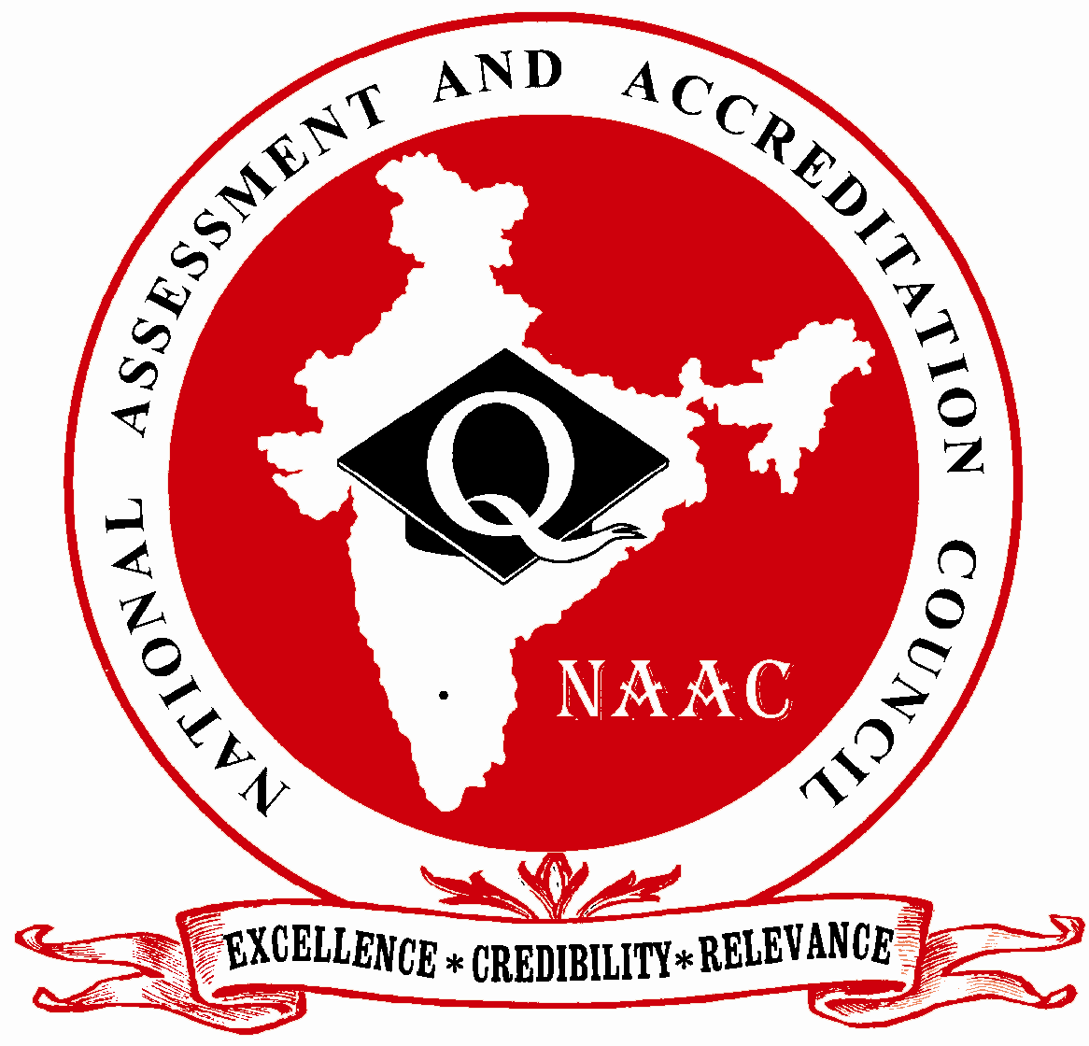

NATIONAL ASSESSMENT AND ACCREDITATION COUNCIL
An Autonomous Institution of the University Grants Commission
P. O. Box. No. 1075, Opp: NLSIU, Nagarbhavi, Bangalore - 560 072 India

The Annual Quality Assurance Report (AQAR) of the IQAC

All NAAC accredited institutions will submit an annual self-reviewed progress report to NAAC, through its IQAC. The report is to detail the tangible results achieved in key areas, specifically identified by the institutional IQAC at the beginning of the academic year. The AQAR will detail the results of the perspective plan worked out by the IQAC. (Note: The AQAR period would be the Academic Year. For example, July 1, 2012 to June 30, 2013)

Part – A
2013-2014
AQAR for the year (for example 2014-15)

1. Details of the Institution
GOPALPUR COLLEGE GOPALPUR, BALASORE

1.1 Name of the Institution
GOPALPUR COLLEGE
1.2 Address Line 1
GOPALPUR
Address Line 2
BALASORE
City/Town
ODISHA
State
756044
Pin Code
gcbls1978@gmail.com
Institution e-mail address
9861173919
Contact Nos.
Dr. RAMA CHANDRA DAS
PRINCIPAL
Name of the Head of the Institution:
06788-237734
Tel. No. with STD Code:
9861173919
Mobile:
NARESH KUMAR PARHI
Name of the IQAC Co-ordinator:
9438320732
Mobile:
gcbls1978@gmail.com
IQAC e-mail address:

ORCOGN-133334
1.3 NAAC Track ID (For ex. MHCOGN 18879)
OR
No-73 Dated 15.07.2012
1.4 NAAC Executive Committee No. & Date:
(For Example EC/32/A&A/143 dated 3-5-2004.
This EC no. is available in the right corner- bottom
of your institution’s Accreditation Certificate)

1.5 Website address:

Web-link of the AQAR:
For ex. http://www.ladykeanecollege.edu.in/AQAR 2012-13.doc
1.6 Accreditation Details
Sl. No. | Cycle | Grade | CGPA | Year of Accreditation | Validity Period
1 | 1st Cycle | C++ |  | 2007 | 5 yrs.
2 | 2nd Cycle | ─ | ─ | ─ | ─
3 | 3rd Cycle | ─ | ─ | ─ | ─
4 | 4th Cycle | ─ | ─ | ─ | ─

15.07.2012
1.7 Date of Establishment of IQAC: DD/MM/YYYY

1.8 Details of the previous year’s AQAR submitted to NAAC after the latest Assessment and Accreditation by NAAC ((for example AQAR 2010-11submitted to NAAC on 12-10-2011)
- AQAR (DD/MM/YYYY)
- AQAR__________________ ________________________ (DD/MM/YYYY)
- AQAR__________________ _______________________ (DD/MM/YYYY)
- AQAR__________________ _______________________ (DD/MM/YYYY)
1.9 Institutional Status

University State √ Central Deemed Private
√

Affiliated College Yes No

√
Constituent College Yes No
√
Autonomous college of UGC Yes No

√
Regulatory Agency approved Institution Yes No
(eg. AICTE, BCI, MCI, PCI, NCI)
√

Type of Institution Co-education Men Women

√

Urban Rural Tribal
√
√
√
Financial Status Grant-in-aid UGC 2(f) UGC 12B
√
Grant-in-aid Self Financing Totally Self-financing

1.10 Type of Faculty/Programme
√

Arts Science Commerce Law PEI (Phys Edu)
√
√

TEI (Edu) Engineering Health Science Management

Others (Specify)
Fakir Mohan University
Vyasa Vihar, Balasore

1.11 Name of the Affiliating University (for the Colleges)

1.12 Special status conferred by Central/ State Government-- UGC/CSIR/DST/DBT/ICMR etc
─
Autonomy by State/Central Govt. / University
─
University with Potential for Excellence UGC-CPE
─

─
─
DST Star Scheme UGC-CE
─
─
UGC-Special Assistance Programme DST-FIST
─
─
UGC-Innovative PG programmes any other (Specify)
─
UGC-COP Programmes
2. IQAC Composition and Activities
07
2.1 No. of Teachers
00
2.2 No. of Administrative/Technical staff
00
2.3 No. of students
2.4 No. of Management representatives
00
01
2.5 No. of Alumni
2. 6 No. of any other stakeholder and
00
Community representatives
00
2.7 No. of Employers/ Industrialists
01
2.8 No. of other External Experts
2.9 Total No. of members
09
2.10 No. of IQAC meetings held 02

2.11 No. of meetings with various stakeholders: No. Faculty
10
02
Non-Teaching Staff 03 Students Alumni 1 Others

04
2.12 Has IQAC received any funding from UGC during the year? Yes No
3,00,000/-
√

If yes, mention the amount
2.13 Seminars and Conferences (only quality related)
(i) No. of Seminars/Conferences/ Workshops/Symposia organized by the IQAC
09
Nil
03
01
05
Total Nos. International National State Institution Level
1. Population Education
2. India and Inclusive democracy
3. Feminism and women empowerment
4. Secularism as putting India first
5. Suadhinata parabarti Odia upaniyasa re palli prustabhumi (State)
6. Political theories in Bharavis Poem
7. Unemployment Problem in India.
8. Economic impact of closure during Agitation (National)
9. Relevance of Studying English language and literature in India (National)

(ii) Themes

2.14 Significant Activities and contributions made by IQAC
- Taking initiative to impress the department the organize the UGC seminar
- Proposed to construct the boundary wall of the college

2.15 Plan of Action by IQAC/Outcome
The plan of action chalked out by the IQAC in the beginning of the year towards quality
Enhancement and the outcome achieved by the end of the year *
Plan of Action | Achievements
- The construction of upstairs administrative building proposed  - Internal audit work proposed  - Separate laboratories for junior & UG students proposed.  - Construction of auditorium planned  - Sports infrastructure facilities planned | - Upstairs of administrative Building completed  - Audit of college account for done by institution level.  - Laboratories for U.G students upgraded  - Construction of auditorium work begin  - Gymnasium items purchased from UGC fund
* Attach the Academic Calendar of the year as Annexure.
√

2.15 Whether the AQAR was placed in statutory body Yes No
√

Management Syndicate any other body
AQAR Submitted to the principal to take up action. As Governing Body has not been constituted the principal has to discuss the matter with president, G.B. As the per discussion the college has applied for accreditation steps for functioning of ladies Hostel in the campus was taken. Building of auditorium was taken up. College website designed.
Provide the details of the action taken

Part – B
Criterion – I

1. Curricular Aspects

1.1 Details about Academic Programmes
Level of the Programme | Number of existing Programmes | Number of programmes added during the year | Number of self-financing programmes | Number of value added / Career Oriented programmes
PhD | ─ | ─ | ─ | ─
PG | ─ | ─ | ─ | ─
UG | 03 | Nil | Nil | Nil
PG Diploma | ─ | ─ | ─ | ─
Advanced Diploma | ─ | ─ | ─ | ─
Diploma | ─ | ─ | ─ | ─
Certificate | ─ | ─ | ─ | ─
Others | ─ | ─ | ─ | ─
Total | 03 | Nil | Nil | Nil

Interdisciplinary | ─ | ─ | ─ | ─
Innovative | ─ | ─ | ─ | ─

1.2 (i) Flexibility of the Curriculum: CBCS/Core/Elective option / Open options
(ii) Pattern of programmes:
Pattern | Number of programmes
Semester | ─
Trimester | ─
Annual | 1st , 2nd & Final University Examination done Annually.

√

─
─
√

1.3 Feedback from stakeholders* Alumni Parents Employers Students
(On all aspects)
─
√

─
Mode of feedback : Online Manual Co-operating schools (for PEI)
*Please provide an analysis of the feedback in the Annexure

1.4 Whether there is any revision/update of regulation or syllabi, if yes, mention their salient aspects.
University regulation applicable for changes in syllabus

1.5 Any new Department/Centre introduced during the year. If yes, give details.
No

Criterion – II
2. Teaching, Learning and Evaluation
2.1 Total No. of permanent faculty
Total | Asst. Professors | Associate Professors | Professors | Others
27 | 18 | 09 | ─ | ─
05
2.2 No. of permanent faculty with Ph.D.
2.3 No. of Faculty Positions Recruited (R) and Vacant (V) during the year
Asst. Professors |  | Associate Professors |  | Professors |  | Others |  | Total
R | V | R | V | R | V | R | V | R | V
00 | 00 | 00 | 01 | 00 | 00 | 00 | 01 | 00 | 02
01
─
─
2.4 No. of Guest and Visiting faculty and Temporary faculty

2.5 Faculty participation in conferences and symposia:

No. of Faculty | International level | National level | State level
Attended Seminars/ Workshops | ─ | ─ | ─
Presented papers | ─ | ─ | ─
Resource Persons | ─ | ─ | ─

2.6 Innovative processes adopted by the institution in Teaching and Learning:
Faculty members are advised to use visual and ICT technology
for classroom teaching

160 Days
2.7 Total No. of actual teaching days
during this academic year
2.8 Examination/ Evaluation Reforms initiated by
As per guideline of university
the Institution (for example: Open Book Examination, Bar Coding,
Double Valuation, Photocopy, Online Multiple Choice Questions)
─
03
─
2.9 No. of faculty members involved in curriculum
Restructuring/revision/syllabus development
as member of Board of Study/Faculty/Curriculum Development workshop
77%
2.10 Average percentage of attendance of students

2.11 Course/Programme wise
Distribution of pass percentage:

Title of the  Programme | Total no. of students appeared | Division
Title of the  Programme | Total no. of students appeared | Distinction % | I % | II % | III % | Pass %
+3 final University Exam | 141 | 41% | 23% | 26% | 28% | 79%

2.12 How does IQAC Contribute/Monitor/Evaluate the Teaching & Learning processes:
IQAC meets twice a year for reviewing result of the final examination. If gives valuable
Suggestions for quality teaching.
2.13 Initiatives undertaken towards faculty development
Faculty / Staff Development Programmes | Number of faculty  benefitted
Refresher courses | 02
UGC – Faculty Improvement Programme | ─
HRD programmes | ─
Orientation programmes | ─
Faculty exchange programme | ─
Staff training conducted by the university | 02
Staff training conducted by other institutions | ─
Summer / Winter schools, Workshops, etc. | 02
Others | ─
2.14 Details of Administrative and Technical staff
Category | Number of Permanent  Employees | Number of Vacant  Positions | Number of permanent positions filled during the Year | Number of positions filled temporarily
Administrative Staff | 06 | 00 | 01 | Nil
Technical Staff | Nil | Nil | Nil | Nil
Criterion – III
3. Research, Consultancy and Extension
3.1 Initiatives of the IQAC in Sensitizing/Promoting Research Climate in the institution
IQAC proposes to conduct various research projects by the faculty members and to avail funding from the UGC

3.2 Details regarding major projects
 | Completed | Ongoing | Sanctioned | Submitted
Number | Nil |  |  | Nil
Outlay in Rs. Lakhs | Nil

3.3 Details regarding minor projects
 | Completed | Ongoing | Sanctioned | Submitted
Number | Nil | Nil | Nil | Nil
Outlay in Rs. Lakhs | Nil | 130000/- | Nil | 212000/-

3.4 Details on research publications
 | International | National | Others
Peer Review Journals | Nil | Nil | Nil
Non-Peer Review Journals | Nil | Nil | Nil
e-Journals | Nil | Nil | Nil
Conference proceedings | Nil | Nil | Nil

3.5 Details on Impact factor of publications:
Nil
Nil

Range Average h-index Nos. in SCOPUS
3.6 Research funds sanctioned and received from various funding agencies, industry and other organisations
Nature of the Project | Duration  Year | Name of the  funding Agency | Total grant  sanctioned | Received
Major projects | Nil | Nil | Nil | Nil
Minor Projects | Nil | Nil | Nil | Nil
Interdisciplinary Projects | Nil | Nil | Nil | Nil
Industry sponsored | Nil | Nil | Nil | Nil
Projects sponsored by the University/ College | Nil | Nil | Nil | Nil
Students research projects  (other than compulsory by the University) | Nil | Nil | Nil | Nil
Any other(Specify) | Nil | Nil | Nil | Nil
Total | Nil | Nil | Nil | Nil

3.7 No. of books published i) With ISBN No. Chapters in Edited Books
Nil
Nil
Nil
ii) Without ISBN No.
3.8 No. of University Departments receiving funds from
UGC-SAP CAS DST-FIST
Nil
Nil
Nil
Nil
Nil
DPE DBT Scheme/funds
3.9 For colleges Autonomy CPE DBT Star Scheme
Nil
Nil
Nil
INSPIRE CE Any Other (specify)
Nil
Nil
Nil
Nil
3.10 Revenue generated through consultancy
Level | International | National | State | University | College
Number | Nil | Nil | Nil | Nil | 8 Departmental  Seminar Organized
Sponsoring agencies | ─ | ─ | ─ | ─ | Honours. Department
3.11 No. of conferences Organized by the Institution
06
3.12 No. of faculty served as experts, chairpersons or resource persons
Nil
Nil
Nil
3.13 No. of collaborations International National Any other
Nil
3.14 No. of linkages created during this year
3.15 Total budget for research for current year in lakhs: Not Assessed
Nil
Nil
From funding agency From Management of University/College
Total
Nil

3.16 No. of patents received this year
Type of Patent |  | Number
National | Applied | Nil
National | Granted | Nil
International | Applied | Nil
International | Granted | Nil
Commercialised | Applied | Nil
Commercialised | Granted | Nil

3.17 No. of research awards/ recognitions received by faculty and research fellows
Of the institute in the year
Total | International | National | State | University | Dist | College
Nil | Nil | Nil | Nil | Nil | Nil | Nil

3.18 No. of faculty from the Institution
Nil
who are Ph. D. Guides
and students registered under them
Nil

3.19 No. of Ph.D. awarded by faculty from the Institution
05

3.20 No. of Research scholars receiving the Fellowships (Newly enrolled + existing ones)
Nil
Nil
Nil
JRF SRF Project Fellows Any other
Nil

3.21 No. of students Participated in NSS events: 2013-2014
50
50
Male Female
NIL
NIL
University level State level
National level International level
NIL
NIL

3.22 No. Of students participated in NCC events:
Nil
Nil
University level State level
National level International level
Nil
Nil

3.23 No. Of Awards won in NSS:
Nil
University level State level
Nil
National level International level
Nil
Nil

3.24 No. Of Awards won in NCC:
University level State level
Nil
Nil
National level International level
Nil
Nil

3.25 No. of Extension activities organized
Nil
Nil
University forum College forum
No
Yes
Self Defence
Active citizenship
NCC NSS Any other

3.26 Major Activities during the year in the sphere of extension activities and Institutional Social Responsibility
- Self Defence programmes for Girls
- Active Citizenship

Criterion – IV
4. Infrastructure and Learning Resources
4.1 Details of increase in infrastructure facilities:
Facilities | Existing | Newly created | Source of Fund | Total
Campus area | A 13.31 | __ | __ | A 13.31
Class rooms | 38 | Nil | Nil | 38
Laboratories | 09 | ─ | ─ | 09
Seminar Halls | Nil | 01 | Own Fund | 01
No. of important equipments purchased (≥ 1-0 lakh) during the current year. | Nil | Nil | ─ | ─
Value of the equipment purchased during the year (Rs. in Lakhs) | Nil | Nil | __ | Nil
Others | ─ | ─ | ─ | ─

4.2 Computerization of administration and library
Student’s Academic Management system college Accounts & library have been computerized.

4.3 Library services:
 | Existing |  | Newly added |  | Total
 | No. | Value | No. | Value | No. | Value
Text Books | 5580 | 743687 | 40 | 4120 | 5620 | 747807
Reference Books | 3492 | 692957 | 30 | 4533 | 3522 | 697490
e-Books | Nil | ─ | ─ | ─ | ─ | ─
Journals | __ | __ | __ | __ | __ | __
e-Journals | Nil | ─ | ─ | ─ | ─ | ─
Digital Database | Nil | ─ | ─ | ─ | ─ | ─
CD & Video | Nil | ─ | ─ | ─ | ─ | ─
Others (specify) | Nil | ─ | ─ | ─ | ─ | ─

4.4 Technology up gradation (overall)
 | Total Computers | Computer Labs | Internet | Browsing Centres | Computer Centres | Office | Depart-ments | Others
Existing | 17 | 01 | 03 | Nil | 08 | SAMS | 4 | Nil
Added | ─ | ─ | ─ | Nil | ─ | ─ | ─ | Nil
Total | 17 | 01 | 03 | Nil | 08 | 01 | 04 | Nil

4.5 Computer, Internet access, training to teachers and students and any other programme for technology
Upgradation (Networking, e-Governance etc.)
Training to Teacher - 01

4.6 Amount spent on maintenance in lakhs :
Nil
i) ICT
7,60,000/-
ii) Campus Infrastructure and facilities
45,000/-
iii) Equipments
─
iv) Others
8,05,000/-
Total:

Criterion – V
5. Student Support and Progression
5.1 Contribution of IQAC in enhancing awareness about Student Support Services
IQAC has contributed a lot in creating awareness among student for social development programmes like cleanliness literacy blood donation, a forestation, social service and many others.

5.2 Efforts made by the institution for tracking the progression
Institution has taken initiatives for infrastructural developments in the college. It aims at opening of Honours in science & commerce streams.

5.3 (a) Total Number of students
UG | PG | Ph. D. | Others
616 | ─ | ─ | ─

(b) No. of students outside the state
Nil
Nil
(c) No. of international students
No | %
No | %
Men Women
Last Year |  |  |  |  |  | This Year
General | SC | ST | OBC | Physically Challenged | Total | General | SC | ST | OBC | Physically Challenged | Total
150 | 111 | 1 | 292 | 0 | 554 | 153 | 145 | 3 | 314 | 1 | 616
Demand ratio 2.39 Dropout % 14%
5.4 Details of student support mechanism for coaching for competitive examinations (If any)
Employment agencies are invited to make aware of the students about job opportunity to students & ex-students

150
No. of students beneficiaries
5.5 No. of students qualified in these examinations

Not intimated
Not intimated

Not intimated

Not intimated

NET SET/SLET GATE CA T
IAS/IPS etc State PSC UPSC Others
Not intimated

Not intimated

Not intimated

Not intimated

5.6 Details of student counselling and career guidance
The Students counselling is made through Information and Employment Cell

50
No. of students benefitted
5.7 Details of campus placement
On campus |  |  | Off Campus
Number of Organizations Visited | Number of Students Participated | Number of Students Placed | Number of Students Placed
Nil | Nil | Nil | Nil

5.8 Details of gender sensitization programmes
The self-defence and self-awareness camps. Organized between 27.10.2014 to 11.11.2014

5.9 Students Activities
5.9.1 No. of students participated in Sports, Games and other events
NIL
Nil
Nil
State/ University level National level International level

No. of students participated in cultural events
Nil
Nil
Nil
State/ University level National level International level

5.9.2 No. of medals /awards won by students in Sports, Games and other events
Nil
Nil
Nil
Sports: State/ University level National level International level
Nil
Nil
Nil
Cultural: State/ University level National level International level
5.10 Scholarships and Financial Support
 | Number of  students | Amount
Financial support from institution | Nil | Nil
Financial support from government | 512 | 7,68,000/-
Financial support from other sources | Nil | Nil
Number of students who received International/ National recognitions | Nil | Nil

5.11 Student organised / initiatives
Nil
Nil
Nil
Fairs : State/ University level National level International level
Nil
Nil
Nil
Exhibition: State/ University level National level International level
3
5.12 No. of social initiatives undertaken by the students

5.13 Major grievances of students (if any) redressed: Water supply to common rooms and drinking
Water facility done.
Criterion – VI
6. Governance, Leadership and Management
6.1 State the Vision and Mission of the institution
1- Scientific, cultural and updated studies.
2-Transparency in official work
3-Using e-devices
4-Time-bound compliance

6.2 Does the Institution has a management Information System
College web-site is being designed to update information management system.

6.3 Quality improvement strategies adopted by the institution for each of the following:
6.3.1 Curriculum Development
Adopted syllabuses prescribed by the university. Guided to follow and analyse of lesson involved. Class room interaction and unit wise texts

6.3.2 Teaching and Learning

Teachers are advised to use computer in teaching-learning process

6.3.3 Examination and Evaluation
Unit test examination and class promotion tests are being conducted.

6.3.4 Research and Development
English-“Difficulties of Odisha Students in learning English”
Odia- “Panchasaka Sahitya re Sri Jagannath saskruti swapra.
Sanskrit- “Cult of Prusottam in Indian scriptures
Economics-“Self Employment scheme implementation-pros & cons

6.3.5 Library, ICT and physical infrastructure / instrumentation
Library is being computerized and web-link planned

6.3.6 Human Resource Management
Planned for computer education and staff training

6.3.7 Faculty and Staff recruitment
Faculty on vacant parts are engaged on contract basic-05 Nos.

6.3.8 Industry Interaction / Collaboration
Nil

6.3.9 Admission of Students
Student is admitted as per Students Admission Management System controlled by H.E. Department Govt. Odisha.

Teaching | Leave for study & faculty development programme
Non teaching | Leave for training & medical benefit
Students | Recommendation stipend & scholarship

6.4 Welfare schemes for

6.5 Total corpus fund generated
0
√

6.6 Whether annual financial audit has been done Yes No

6.7 Whether Academic and Administrative Audit (AAA) has been done?
Audit Type | External |  | Internal
Audit Type | Yes/No | Agency | Yes/No | Authority
Academic | No. | __ | No | Academic Council
Administrative | Yes | Chartered firms | Yes | Internal audit squad

6.8 Does the University/ Autonomous College declare results within 30 days?

√
For UG Programmes Yes No

For PG Programmes Yes No
6.9 What efforts are made by the University/ Autonomous College for Examination Reforms?
The University is planning for semester system

6.10 What efforts are made by the University to promote autonomy in the affiliated/constituent colleges?
Not intimated

6.11 Activities and support from the Alumni Association
Alumni meetings are organised and Ex-student are intimated to assist the college in administration, student’s support & progression

6.12 Activities and support from the Parent – Teacher Association
Parents are called to discuss about students’ problem and motivation in study.

6.13 Development programmes for support staff
Planned for orientation and training programme.

6.14 Initiatives taken by the institution to make the campus eco-friendly
Steps taken for cleanliness through NSS and YRC students. Co-ordination between different sections provided to make the campus green.

Criterion – VII
7. Innovations and Best Practices
7.1 Innovations introduced during this academic year which have created a positive impact on the
Functioning of the institution. Give details.
Blood donation camp, rally, students’ participation in Sports and Games. Gymnasium established.

7.2 Provide the Action Taken Report (ATR) based on the plan of action decided upon at the
beginning of the year
Meeting of consideration the student’s performance in university exam discussed and the departments are made aware of the problems of student’s weakness/strength.

7.3 Give two Best Practices of the institution (please see the format in the NAAC Self-study Manuals)
- Students Whole-heartedly work as Volunteers.
- Students Practise Yoga for their moral Development.

*Provide the details in annexure (annexure need to be numbered as i, ii,iii)
7.4 Contribution to environmental awareness / protection
The student’s seminar organised on environmental problem and . A course of Environmental science implemented by University.

√
7.5 Whether environmental audit was conducted? Yes No

7.6 Any other relevant information the institution wishes to add. (for example SWOT Analysis)
Two junior colleges one general and one vocational managed by the staff of the college. Horticulture and fishery projects’ maintained.

8. Plans of institution for next year
The institution proposer for curricular development with well equipped laboratories and Honours courses in Science and Commerce streams.

Name : Naresh Kumar Parhi Name : Dr. Rama Chandra Das
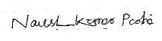


_______________________________ _______________________________
Signature of the Coordinator, IQAC Signature of the Chairperson, IQAC

_______***_______

